 

***Session 3***

***1-09-2022***

***---------------------------------------------------------***

***Tasks***

**1-What’s conda and mini conda, and what’s difference?**

* Conda is an open-source package management system and environment management system that runs on Windows, macOS, and Linux. Conda quickly installs, runs, and updates packages and their dependencies. Conda easily creates, saves, loads, and switches between environments on your local computer.
* Miniconda is a free minimal installer for conda. It is a small, bootstrap version of Anaconda that includes only conda, Python, the packages they depend on, and a small number of other useful packages
* Anaconda comes with over 150 data science packages, whereas miniconda comes with only a handful.
* Anaconda has a graphical user interface (GUI) called the Navigator, while miniconda has a command-line interface.

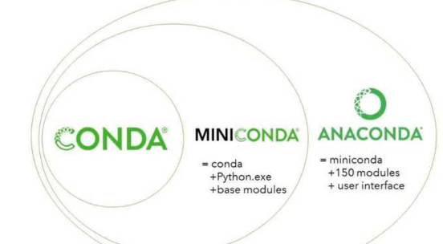

**2-code not clean and converted to clean code?**

[**ryanmcdermott/clean-code-javascript: Clean Code concepts adapted for JavaScript (github.com)**](https://github.com/ryanmcdermott/clean-code-javascript)

**3-what’s framework? why use it? advantages and dis advantages?**

* A framework in programming is a tool that provides ready-made components or solutions that are customized in order to speed up development.
* A framework is a structure that you can build software on. It serves as a foundation, so you're not starting entirely from scratch. Frameworks are typically associated with a specific programming language and are suited to different types of tasks.
* Using frameworks saves time and reduces the risk of errors. You don't need to write everything from the ground up, so there's less chance of introducing errors. Plus, frameworks have already been tested, so there's less to worry about.

|  |  |
| --- | --- |
| **Advantages** | **Disadvantages** |
| * More secure code * Simpler testing and debugging * Avoiding duplicate code * Clean and easily adaptable code * Able to focus on writing code specific to the project | * Framework Limitations  **Learning the Framework and Not the Language****Unnecessary Extras**  * Speed |

**4-5 famouse proseccors in pc and mobile and why?**

* Intel
* AMD
* Apple
* Nvidia
* Qualcomm

**Mobile:**

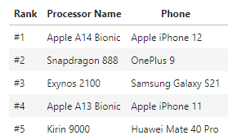

**5-how make to make recursion faster than iteration on processors that doesn’t support multi threads?**

[Improving efficiency of recursive functions (article) | Khan Academy](https://www.khanacademy.org/computing/computer-science/algorithms/recursive-algorithms/a/improving-efficiency-of-recursive-functions)

**6-Hashtable? why we use hashtable in unordered set ?**

Hash Table is a data structure which stores data in an associative manner. In a hash table, data is stored in an array format, where each data value has its own unique index value. Access of data becomes very fast if we know the index of the desired data

## **Hashing**

Hashing is a technique to convert a range of key values into a range of indexes of an array. We're going to use modulo operator to get a range of key values. Consider an example of hash table of size 20, and the following items are to be stored. Item are in the (key,value) format.

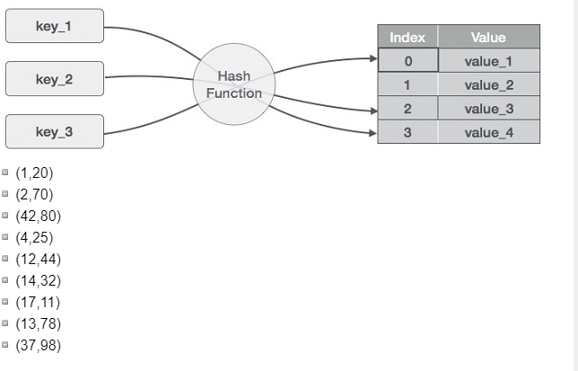

## **Unordered sets :**

Unordered sets are containers that store unique elements in no particular order, and which allow for fast retrieval of individual elements based on their value. In an unordered_set, the value of an element is at the same time its key, that identifies it uniquely.

These sets are implemented using hash tables, where each entry is randomly added to the table to achieve a time complexity of O(1).

**7-how to print type of error in try,catch?**

try:

lst = ['Alice', 'Bob', 'Carl']

print(lst[3])

except Exception as e:

print(e)

**notes:**

**on average pc can do 10^9 operations and that based on prsocessors**